SIerra Leone
TENDER APPLICATION TEMPLATE
INVITATION FOR TENDER:

[INSERT APPLICANT NAME (OPERATOR)]

SECTION A

APPLICANT DETAILS
AND FINANCIAL INFORMATION

STANDARD APPLICATION FOR ENTERING INTO PETROLEUM AGREEMENTS

Completed Applications should be sent to:

PETROLEUM DIRECTORATE SIERRA LEONE
20 Mandalay Street, Kingtom, Freetown Sierra Leone
PETROLEUM DIRECTORATE SIERRA LEONE
20 Mandalay Street, Kingtom, Freetown Sierra Leone
PETROLEUM DIRECTORATE SIERRA LEONE
20 Mandalay Street, Kingtom, Freetown Sierra Leone
PETROLEUM DIRECTORATE SIERRA LEONE
20 Mandalay Street, Kingtom, Freetown Sierra Leone
PETROLEUM DIRECTORATE SIERRA LEONE
20 Mandalay Street, Kingtom, Freetown Sierra Leone
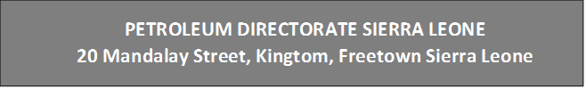
PETROLEUM DIRECTORATE SIERRA LEONE
20 Mandalay Street, Kingtom, Freetown Sierra Leone
PETROLEUM DIRECTORATE SIERRA LEONE
20 Mandalay Street, Kingtom, Freetown Sierra Leone
PETROLEUM DIRECTORATE SIERRA LEONE
20 Mandalay Street, Kingtom, Freetown Sierra Leone
PETROLEUM DIRECTORATE SIERRA LEONE
20 Mandalay Street, Kingtom, Freetown Sierra Leone
PETROLEUM DIRECTORATE SIERRA LEONE
20 Mandalay Street, Kingtom, Freetown Sierra Leone
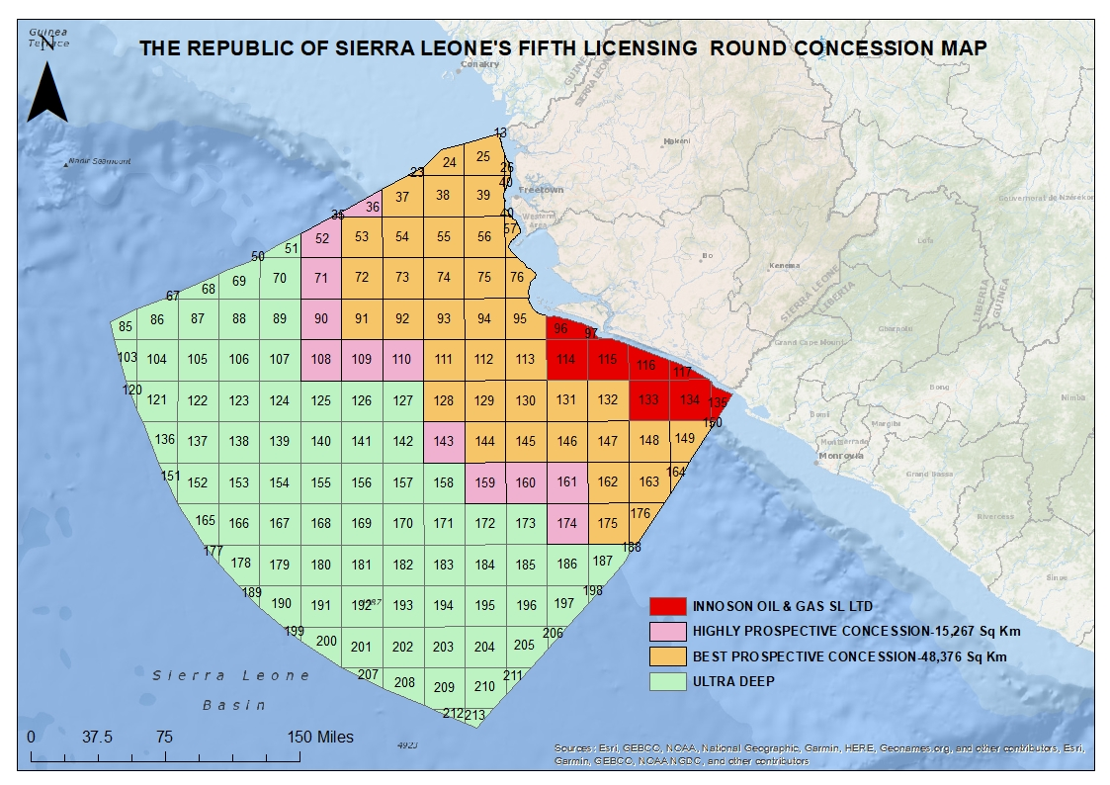
PETROLEUM DIRECTORATE SIERRA LEONE
20 Mandalay Street, Kingtom, Freetown Sierra Leone
PETROLEUM DIRECTORATE SIERRA LEONE
20 Mandalay Street, Kingtom, Freetown Sierra Leone
Figure 1: Concession Map for Fifth Licensing Round (May 2022)
Part l | Name(s) of Applicant(s) and Proposed Operator

- Where there is more than one Applicant please list the names according to the size of the proposed percentage interest, starting with the largest percentage:

Name(s) of Applicant(s)  (as in Certificate of Incorporation) |  | BLOCKS  Applying for. | Proposed Percentage Interest(s)  (These should total 100)
.
1

OPERATOR
2

3

4

  - State the name of the proposed Operator Company and whom to contact for correspondence regarding this application:

a. | Name of proposed Operator Company:
b. | Name of contact:
c.c. | Address of contact:
d. | Telephone number of contact:
e. | E-mail address of contact:

1.2 Details of the Company Representative in Sierra Leone:

a. | Name of proposed local company representative:  (attach details)
b. | Address of contact:
c. | Telephone number of contact:
d. | E-mail address of contact:

Part ll | Licence Area applied for.

- Licence Area | Block Numbers Incorporated:

Location map of Licence Area applied for:

Part lII | Additional Information

Please also provide:

  - A brief description of the technical and industrial resources available to the Applicant.

  - Particulars of financial resources available to the Applicant, including capital, credit facilities and guarantees (including parent company guarantees).

