SIerra Leone
TENDER APPLICATION TEMPLATE
INVITATION FOR TENDER:

[INSERT APPLICANT NAME (OPERATOR)]

SECTION B

TECHNICAL SUMMARY

STANDARD APPLICATION FOR ENTERING INTO PETROLEUM AGREEMENTS

Completed Applications should be sent to:

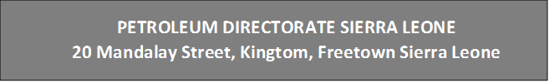
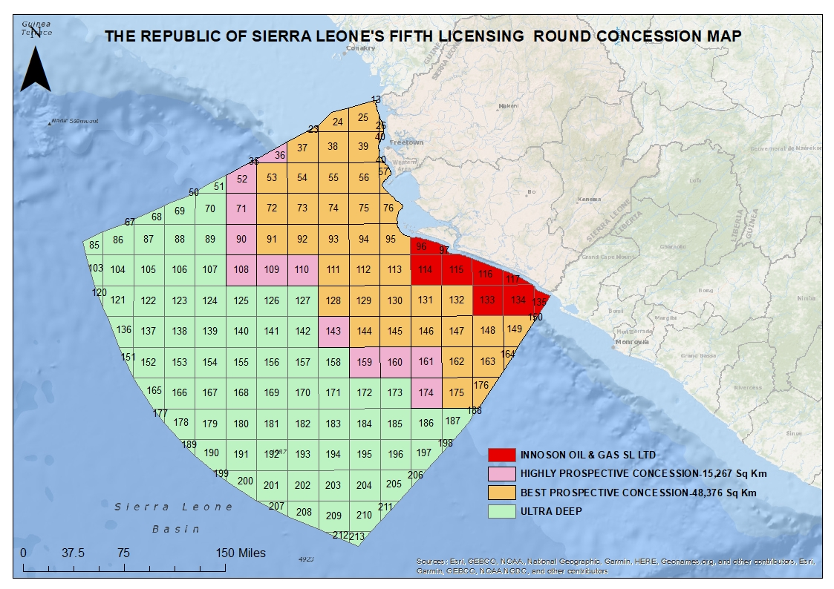
PETROLEUM DIRECTORATE SIERRA LEONE
20 Mandalay Street, Kingtom, Freetown Sierra Leone
PETROLEUM DIRECTORATE SIERRA LEONE
20 Mandalay Street, Kingtom, Freetown Sierra Leone
Figure 1: Concession Map for Fifth Licensing Round (May 2022)
Part l | Technical Assessment

- Regional Overview
Give a concise account of your assessment of the regional position and geological significance within the basin/area of the Licence Area being applied for including:
- Play Fairway (Structure / Play types /Source / Seal / Reservoir)
- Existing discovery wells
- Other wells

- Technical Database
Provide a summary of your geotechnical database in Sierra Leone including:
- Seismic Data
- Well Data
- Gravity & Magnetic Data
- Multi-Client Studies
- Other Data

- Leads & Prospects
Give a brief summary of any specific Leads & Prospects identified in the Licence Area applied for, together with reservoir formation and an assessment of the estimated reserves.

- Prospect ID
- Lead ID
- Reservoir Formation
- Source Rock
- Trapping Mechanism / Seal
- Estimated Reserves

Location map of selected Leads and Prospects in the Licence Area applied for:

- Firm Wells
If a Firm well is offered in the Initial Exploration Period, then please provide:
- Blocks
- Prospect ID
- Reservoir Formation
- Source Rock
- Trapping Mechanism / Seal
- Estimated Reserves
- Water Depth
- Depth (TD-TVDss)
- Stratigraphic Target
- Well Prognosis (A4)
- Interpreted seismic line through proposed well location (A4)
- Time/Depth Structure Map showing location of the well (A4)

- Contingent Wells
Details of any contingent well that is dependent upon discoveries in the primary exploration target.
- Blocks
- Prospect ID
- Reservoir Formation
- Source Rock
- Trapping Mechanism / Seal
- Estimated Reserves
- Water Depth
- Depth (TD-TVDss)
- Stratigraphic Target
- Well Prognosis (A4)
- Interpreted seismic line through proposed well location (A4)
- Time/Depth Structure Map showing location of the well (A4)

- Existing Discoveries
Details of plans to re-evaluate any existing discoveries.
- Technical Assessment
- Economics
- Commercial
- Plans & Timing

NOTE: THE APPLICATION IS REQUESTED TO BE PROVIDED AS TWO PAPER COPIES OF
SINGLE SIDED A4 DOCUMENT AND A DIGITAL COPY IN PDF FORMAT (DVD or
USB).

Part ll | Exploration Work Program

Give a description of the proposed work program and the accompanying budget for the Licence Area applied for. Specify the minimum exploration program and minimum expenditure for the exploration period and any extension period (which may last a maximum of 7 years). Please Note: Extension periods are subject to licensee application and approval of the Petroleum Directorate.

Initial Exploration  Period (IEP)  3 Years | Environmental Studies | Titles
Initial Exploration  Period (IEP)  3 Years | Environmental Studies | Expected cost (US$)
Initial Exploration  Period (IEP)  3 Years | Geotechnical Studies | Titles
Initial Exploration  Period (IEP)  3 Years |  | Expected cost (US$)
Initial Exploration  Period (IEP)  3 Years | 2D Seismic Acquisition | Amount (km)
Initial Exploration  Period (IEP)  3 Years | 2D Seismic Acquisition | Expected cost (US$)
Initial Exploration  Period (IEP)  3 Years | 3D Seismic Acquisition | Amount (sq km)
Initial Exploration  Period (IEP)  3 Years | 3D Seismic Acquisition | Expected Cost (US$)
Initial Exploration  Period (IEP)  3 Years | Exploration Wells | Number of firm Wells
Initial Exploration  Period (IEP)  3 Years | Exploration Wells | Number of Contingent Wells
Initial Exploration  Period (IEP)  3 Years | Exploration Wells | Depth (TD-TVDss)
Initial Exploration  Period (IEP)  3 Years | Exploration Wells | Stratigraphic Target(s)
Initial Exploration  Period (IEP)  3 Years | Exploration Wells | Expected Cost (US$)
 |  | Estimated Expenditure IEP |  | $
First Extension  Period (FEP)  2 Years | Environmental Studies | Title
First Extension  Period (FEP)  2 Years | Environmental Studies | Expected cost (US$)
First Extension  Period (FEP)  2 Years | Geotechnical Studies | Title
First Extension  Period (FEP)  2 Years | Geotechnical Studies | Expected cost (US$)
First Extension  Period (FEP)  2 Years | Seismic acquisition | 2D Amount (sq km)
First Extension  Period (FEP)  2 Years | Seismic acquisition | 3D Amount (sq km)
First Extension  Period (FEP)  2 Years | Seismic acquisition | Expected Cost (US$)
First Extension  Period (FEP)  2 Years | Exploration wells | Number of Wells
First Extension  Period (FEP)  2 Years | Exploration wells | Depth (TD-TVDss)
First Extension  Period (FEP)  2 Years | Exploration wells | Stratigraphic Target
First Extension  Period (FEP)  2 Years | Exploration wells | Expected Cost (US$)
 |  | Estimated Expenditure FEP |  | $
Second Extension  Period (SEP)  2 Years  subject to total length  of exploration Period  which may last up to 7 years | Environmental Studies | Title
 | Environmental Studies | Expected cost (US$)
 | Geotechnical Studies | Title
 | Geotechnical Studies | Expected cost (US$)
 | Seismic acquisition | Amount (sq km)
 | Seismic acquisition | Expected Cost (US$)
 | Exploration wells | Number of Wells
 | Exploration wells | Depth (TD-TVDss)
 | Exploration wells | Stratigraphic Target
 | Exploration wells | Expected Cost (US$)
 |  | Estimated Expenditure SEP |  | $

