SIerra Leone
TENDER APPLICATION TEMPLATE
INVITATION FOR TENDER:

[INSERT APPLICANT NAME (OPERATOR)]

SECTION C

COMMERCIAL PROPOSAL

STANDARD APPLICATION FOR ENTERING INTO PETROLEUM AGREEMENTS

Completed Applications should be sent to:

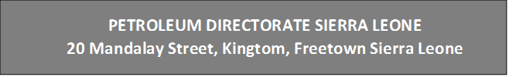

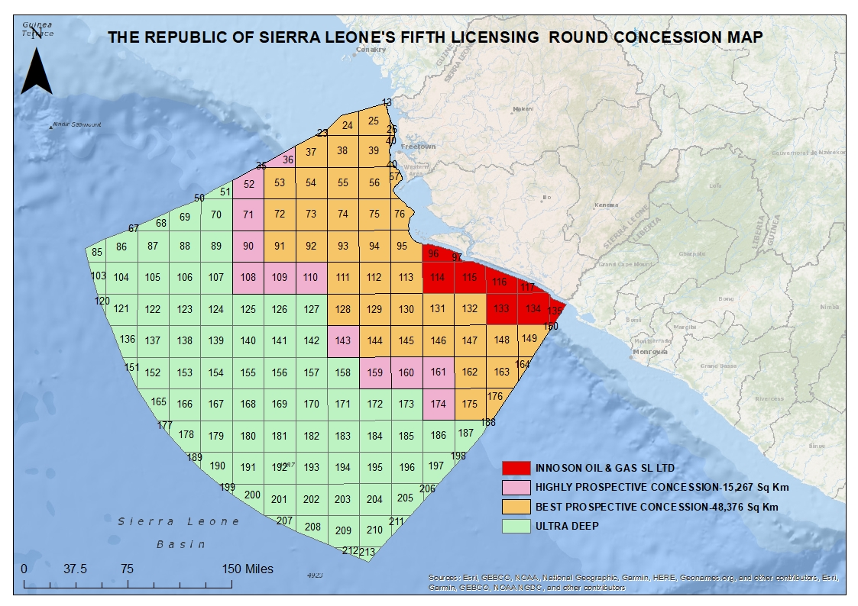
PETROLEUM DIRECTORATE SIERRA LEONE
20 Mandalay Street, Kingtom, Freetown Sierra Leone
PETROLEUM DIRECTORATE SIERRA LEONE
20 Mandalay Street, Kingtom, Freetown Sierra Leone
Figure 1: Concession Map for Fifth Licensing Round (May 2022)

Part l | Fees

- Prequalification

The Operator confirms that all members of the “Applicant Group” are qualified to participate in the Direct Negotiations:

- Operator
- Partner 1
- Partner 2
- Partner X

Signed: _______________________________________________________
Name:
Title:
Company:

- Application Fee
The Operator confirms that the Application Fee of US $ 30,000 for the License Area applied for has
been paid:

Signed: _______________________________________________________
Name:
Title:
Company:

Note: A separate Application Fee is required to be paid for each License Area applied for.

Part ll | Biddable Items

Please complete the Table below:

PERIOD | YEARS  PERIOD | DESCRIPTION | BIDDABLE ITEMS
State Participation | Expl. | Minimum carried interest of 10 % | %
Signature Bonus | Expl. |  | $
Initial Exploration Period | 3 | Minimum Expenditure for  Bank Guarantee | $
First Extension Period | 2 | Minimum Expenditure for  Bank Guarantee | $
Second Extension Period | 2 | Minimum Expenditure for  Bank Guarantee | $
Development Bonus | Dev | Payment on approval of the Development Plan | $
Production Bonus | Dev | Payment on commencement of initial commercial production | $
Technology Bonus | Expl. | Payment on anniversary of effective date | $
Training Fund - Exploration | 7 |  | $
Training Fund - Development | 23 |  | $
Training Fund - Production | 23 |  | $
Social Projects - Exploration | 7 |  | $
Social Projects - Development | 23 |  | $
Social Projects - Production | 23 |  | $

*The Total Exploration License Period may last a maximum of 7 years. Please Note: Extension periods are subject to licensee application and approval by the Petroleum Directorate.

Part llI | Additional Aspects

  - Training & Development

Please outline your proposals with respect to the training and employment of citizens of Sierra Leone.

  - Social Projects
Please outline your proposals with respect to Social Projects to the benefits of the citizens of Sierra Leone, include examples where relevant from other Countries.

  - Other Matters
The Applicant may include here other matters which in the opinion of the Applicant is relevant to the Application.

