SIerra Leone
TENDER APPLICATION TEMPLATE
INVITATION FOR TENDER:

[INSERT APPLICANT NAME (OPERATOR)]

SECTION D

HEALTH, SAFETY AND ENVIRONMENT “HSE” SUMMARY

STANDARD APPLICATION FOR ENTERING INTO PETROLEUM AGREEMENTS

Completed Applications should be sent to:


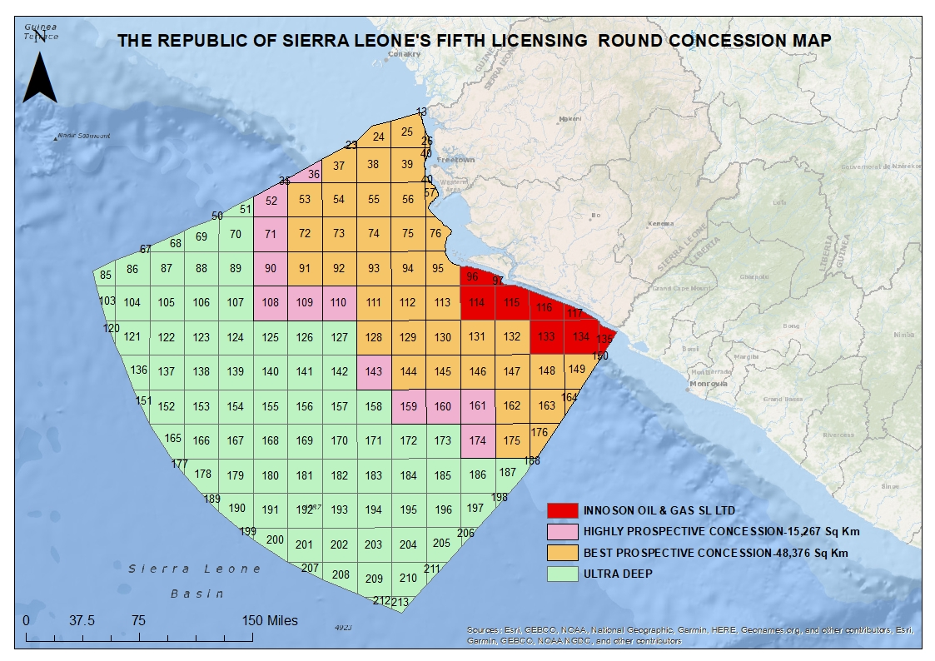
PETROLEUM DIRECTORATE SIERRA LEONE
20 Mandalay Street, Kingtom, Freetown Sierra Leone
PETROLEUM DIRECTORATE SIERRA LEONE
20 Mandalay Street, Kingtom, Freetown Sierra Leone
Figure 1: Concession Map for Fifth Licensing Round (May 2022)

Ref: Petroleum Law 2011 & Environmental Protection Act 2008

Applicants are asked to submit copies of their HSE record and information in A4 Format.
- Introduction
The Petroleum Directorate recognizes that a favourable health, environment and safety culture is needed to ensure continual development and improvement of health, environment and safety. Applicants must submit details of their Health, Safety (Safety Culture) and Environment protection systems.
Harm or danger to people, the environment or to installations, pipelines and equipment must be prevented or limited. A high standard of operational regularity and safety is in the interest of all petroleum industry stakeholders. To reach the level of acceptable conduct systematic procedures and assessments must be made and documented in all phases of the petroleum activities.
The Applicant thus must demonstrate its HSE systems and their implementation with regard to risk reduction through the Applicant’s choice and implementation of technical, operational or organisational solutions.
- Operator QHSE Information
Applicants must provide evidence of proper operational procedures and sensitivity related to issues surrounding health, safety and the environment. The purpose is for the Company to demonstrate its ability to observe international standards. Companies are required to submit:
  - QHSE Policy Statement.
  - Evidence of established and implemented QHSE Management System(s).
  - QHSE certification(s) according to best international industry practice (e.g., ISO certification 9001, ISO 14001 and/or OHSAS 18001), with copies of certificates approved by the awarding official entities.
  - A copy of the Quality, Health, Safety and Environment Management System(s) (QHSEMS), or equivalent.
  - A copy of Corporate Social Responsibility reports or initiatives for the past three (3) years.
  - QHSE record of material events for the previous three (3) years including oil spills, site fatalities and injuries, major fires and explosions, mechanical/structural failures, emissions and waste, and main remedial efforts.
- License Area Specific QHSE Information
  - An assessment of the impact which the proposed exploration operations may have on the environment.
  - A plan for the prevention of pollution, the handling of waste, the safeguard of the natural resources and minimisation of the harmful effects of petroleum operations.
  - The Applicant’s proposals for insurance for petroleum operations, including accidental death and health insurance cover for its employees.

